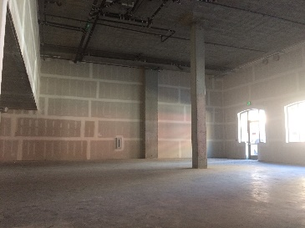**Commercial: 423 7th Street, Oakland, CA 94607**

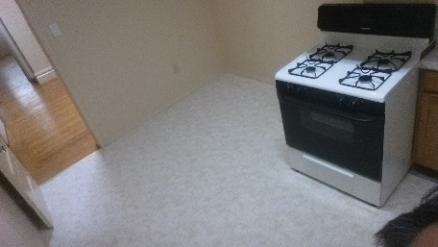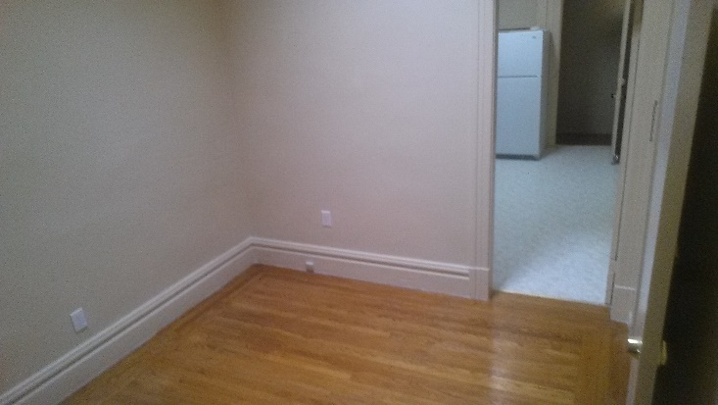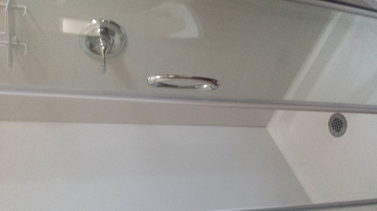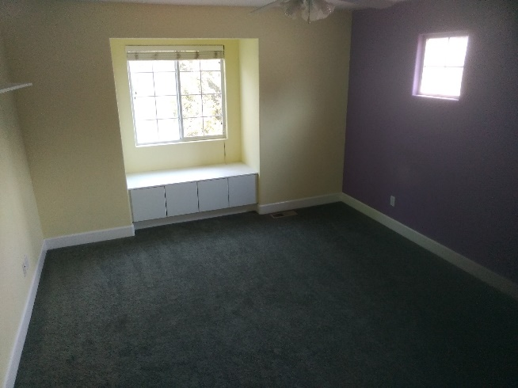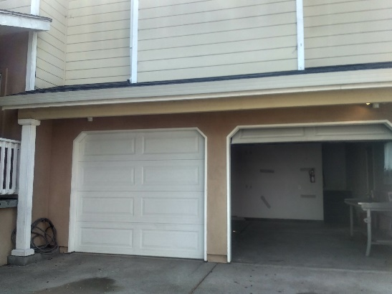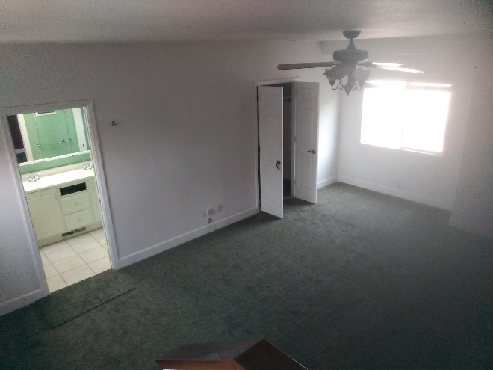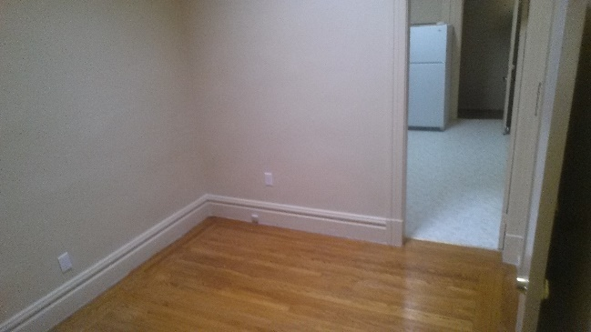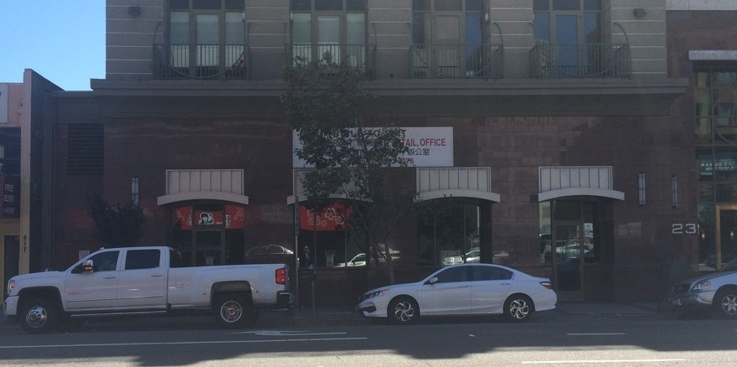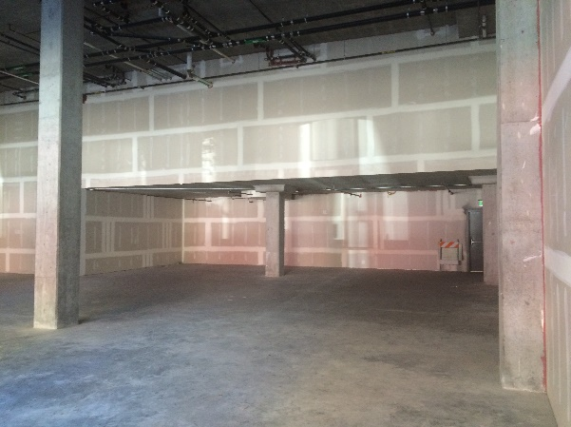**$6,216 / Month**

2nd Residential Rental (Above) at 59 Lapidge, San Francisco, CA with 1 private bedroom, private living room and newly furnished and flooring

Disclaimer: This information is deemed reliable, but not verified or guaranteed.

1st Residential Rental (Below) at 1205 S56th St. Richmond City, CA with 4 bedroom, 2 stories and 2 car space garage private living room and newly furnished and flooring

Disclaimer: This information is deemed reliable, but not verified or guaranteed.

PACIFIC Sales & Management

O – (510) 763-8600

Francis Ha BRE #01798336

C – (415) 517-1034

francisha.psm@gmail.com

Disclaimer: This information is deemed reliable, but not verified or guaranteed.

Features:

- Commercial Building for Lease

- 3108 Sq Ft

- $2 / Sq Ft

- High Ceiling

- Retail Space

- Perfect for a Restaurant, Office, Storage, etc.

- I-580, I-880, Oakland Chinatown, and Jack London Square Nearby

Call quickly to get more info or to take a look at this space!